Technology Making Moves on Us

A decade ago, it was fairly normal to hear people express resistance towards technology. Many were set in their ways, saying they didn’t care for iPads smartphones, or touch-screens and were perfectly fine and capable functioning without computerized gadgets cluttering their space. Today in 2014, this type of chatter has significantly quieted down. As technology continues to become more accessible to everyone, not just the tech-savvy nerds, it is proving to be increasingly beneficial to adapt to and use throughout everyday aspects of life.

The Social
Technology platforms that house social media, such as tablets, computers and phones, have undeniably helped people stay connected in ways unimaginable. Friends, family, acquaintances and work colleagues have the ability to communicate faster and more often, which indirectly and directly integrates our lives. A true sense of community is built whether for personal or business uses or even better, humanitarian causes like the UNICEF Tap Project. This campaign to donate water to those in need leverages the concept of smartphone usage and is promoted virally by social media sharing – a prime example of how a hybrid of technology and social media can advance society as a whole.

The Travel
Looking back is always a good way to gauge just how much has progressed. Getting from Point A to Point B used to involve plopping down in front of a desktop computer monitor, going on MapQuest to find a route, and sending those directions to the printer (a rare find these days if not at the office). Now all that’s needed is the Google Maps app on your phone or even better, telling the car GPS to take you there – a pseudo chauffeur really.

Efficiencies have also improved in another form of transportation that is airplanes. When we fly now, a Wi-Fi option is expected. Though some may be on vacation, others are on the clock – time is money, so when you’re able to hop on the internet to check some work emails during a cross-country flight, technology becomes clutch for productivity, helping advance your career. Soaring potential will even further progress the day every single airline offers free Wi-Fi… and the business class goes wild!

The Home
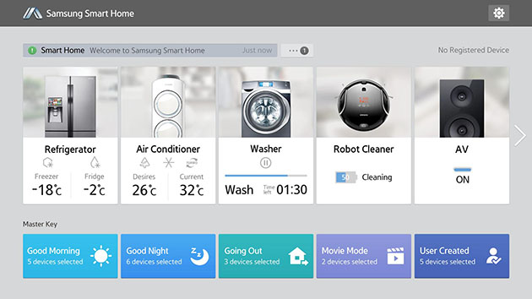
Housekeeping is a pain. Instead of working to keep your house comfortable, technology has made it possible to have your home be of service to you. The concept of a smart home has made its introduction and it’ s exactly as it sounds – a home that is smart in every sense. For example, Samsung, a pioneer in patented technologies, has invented a microwave that automatically adjusts temperatures using Sensor Cook Technology so that the defrost button doesn’t accidentally cook the frozen chicken you were simply trying to unfreeze. Furthermore, it is one of the first to create a suite of appliances and smart entertainment systems that can be connected and managed through a single, integrated platform. Now that’s, where the living is easy.

The Health
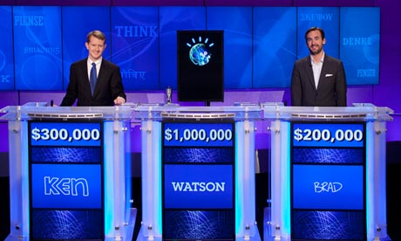
Medical technology advancements are crucial to saving lives and are warmly welcomed in an industry that needs all the health care it can get. Next to the doctors themselves, IBM’s supercomputer, “Watson,” has become a rising hero in the medical field. With artificial intelligence, the computer demonstrated it was more than just a pretty monitor when it defeated two human champions on “Jeopardy.” Watson’s life outside the silver screen consists of analyzing the entire genome, biometric, environmental and personal data including diet and activity level, of patients seeking help. The supercomputer’s extraordinary capability to sift through complex analysis is leading to a better understanding and a healthier tomorrow.

Technology has advanced all aspects of our lives. From socializing and traveling, to our homes and health, it is here to stay and continue to evolve us. The previously hesitant have learned to embrace it and now all the masses can gravitate towards change-your-life experiences using technology.

Resources:

http://tap.unicefusa.org/

http://skift.com/2014/06/27/why-airlines-and-airports-alike-need-to-embrace-free-wi-fi/

http://www.samsung.com/us/showcase/smart-home-appliance-washer-dryer-and-refrigerators

http://www.samsung.com/us/news/22331

http://www.beckershospitalreview.com/news-and-analysis/the-future-of-medicine-5-new-technologies-transforming-the-field.html

