Twitter Tips and How Some Companies Are Killing It

Twitter is the choice weapon for businesses. First off, when you use Twitter, there is virtually no overhead (except paying a recent college grad who is young, social-media savvy, hungry, driven and most importantly cheap labor, to man the account). Moreover, it is a viral, engaging platform for promotion that utilizes relationship-building and reputation management tactics to ensure real customer loyalty. Now, that’s a lot of marketing buzzwords, but all are relevant in making your company successful through one of the most powerful advertising avenues out there.
(Image Source: http://www.virtualsocialmedia.com/wp-content/uploads/2012/09/How-to-Utilize-Twitter-for-Your-Business.jpg)
Follow the Leader
There’s proof in the numbers that Twitter works for boosting business. T-Mobile, Barack Obama and Jet Blue are a few brands that kill it in the Twittersphere.

T-Mobile
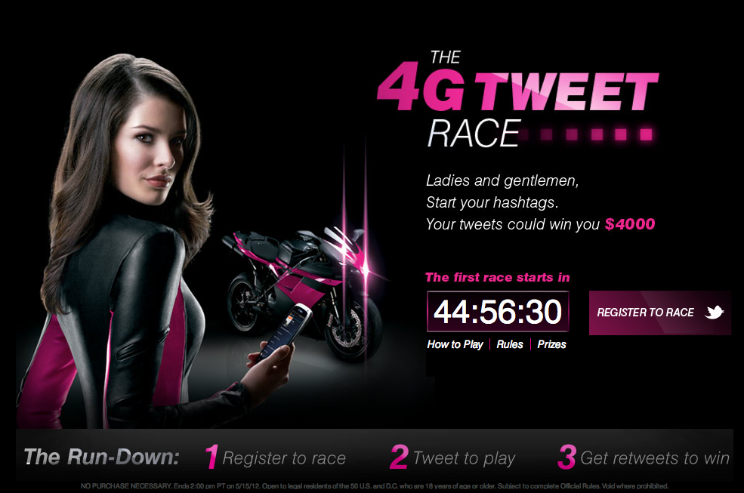
(Image Source: www.tmonews.com)

T-Mobile most recently took to Twitter to promote its innovative LG G3 “Phablet” (smartphone + tablet). To help amp up hype and interest, an LG G3 was given to a lucky follower each day of June leading up to the product launch. Aside from consistently running giveaways, T-Mobile also succeeds in the Twitter realm for customer service, providing speedy responses to those who tweet the company.

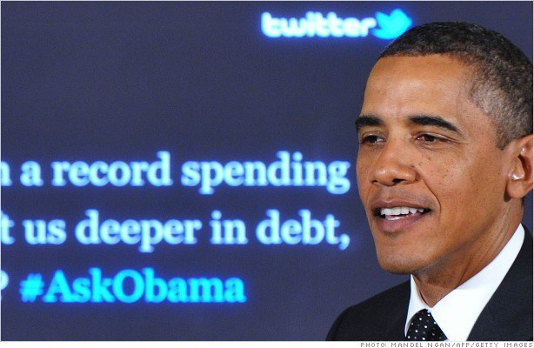
President Obama
(Image Source: http://economy.money.cnn.com/tag/white-house/)

Throughout both Presidential elections, President Barack Obama heavily utilized Twitter’s free space to spread his message and voice his opinions and visions. Paid promoted tweets were also integrated in his campaign strategy, methodically timed to show up in feeds/timelines and while searching for trends. The President’s wins can be accredited to extremely valuable posts that had a major influence on voter attitudes during crucial election events. Currently, President Obama regularly tweets to maintain a rapport with the very proactive population in the Twitter arena.

Jet Blue
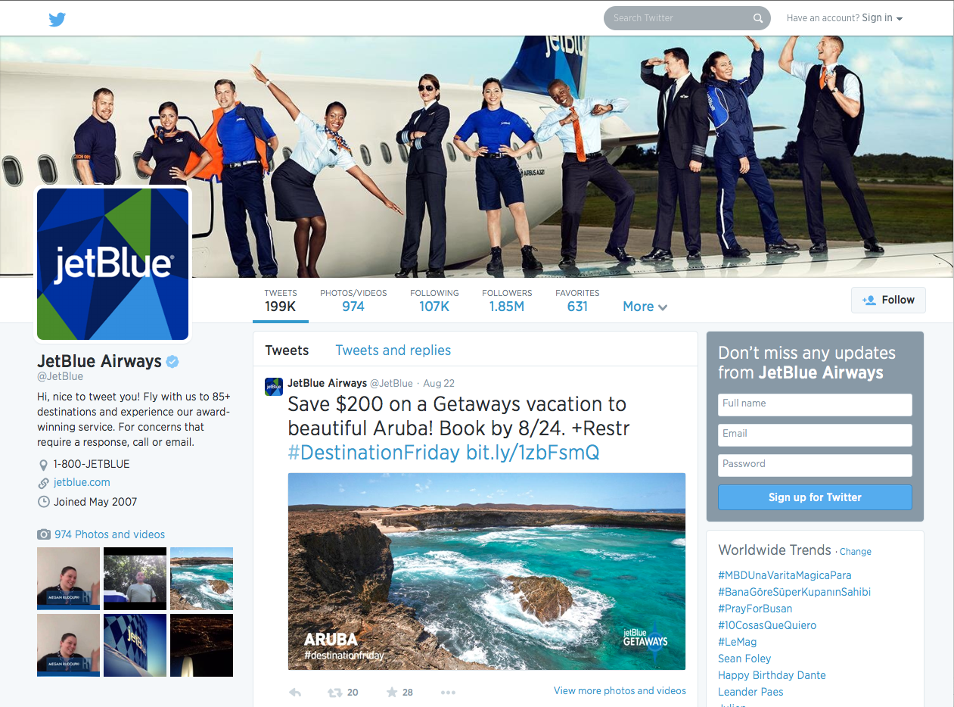
(Image Source: https://twitter.com/jetblue)

In the competitive travel industry filled with noise, airlines rely on timing and customer loyalty – aligning perfectly with the principles Twitter thrives on. Jumping from 10K followers in 2009 to the 1.85 million it has today, Jet Blue Airways’ Twitter usage has been very sound and very effective. On top of deal-of-the-moment type tweets, JetBlue continually creates a brand persona – lately it exercised corporate responsibility with humanitarian efforts, raising awareness and donations for a reading program. Hashtags like “#SoarWithReading” were implemented to expand visibility of the cause.

More Knowledge = More Power
Now that your head is exploding from ideas inspired by business champions, here are even more tips to help you hit the jackpot.

1. Use Twitter as if you actually use Twitter.
You can spot a phony from a mile away. Practice using Twitter – learn the terminology and everyday ins and outs. That way, you’ll be able to relate to your target and speak the lingo for better reception and response.

2. Establish industry expertise.
Share relevant news and supply commentary to establish your brand as a legitimate source and thought leader, thus fueling consumer trust.

3. Hashtag wisely.
Hashtags are a great tool to tap into conversations and infiltrate your brand into specific social networks. Just don’t start hashtagging everything in one post – it can come off as overwhelming, non-genuine and downright annoying.

4. Do unto others, as you would have them do unto you.
In Twitterverse, this means retweet those who tweet about you in order to add a humanized element and increase personalized attention.

5. Rich media will make you rich.
Mix in pictures and video for increased engagement that is refreshing in a Twittersphere submerged in words.

Start tweeting to gain return on investment. By following the footsteps of leading brands and implementing top twitter strategies, your business can flourish in a fun and surprisingly meaningful way.

Resources:
http://www.droid-life.com/2014/05/27/t-mobile-announces-contest-for-lg-g3-win-a-beta-model-before-official-release/

https://twitter.com/JetBlue

https://business.twitter.com/success-stories

https://business.twitter.com/success-stories/barack-obama

http://www.steamfeed.com/10-twitter-best-practices-2014/

http://www.forbes.com/sites/kenkrogue/2013/08/30/31-twitter-tips-how-to-use-twitter-tools-and-twitter-best-practices-for-business/

